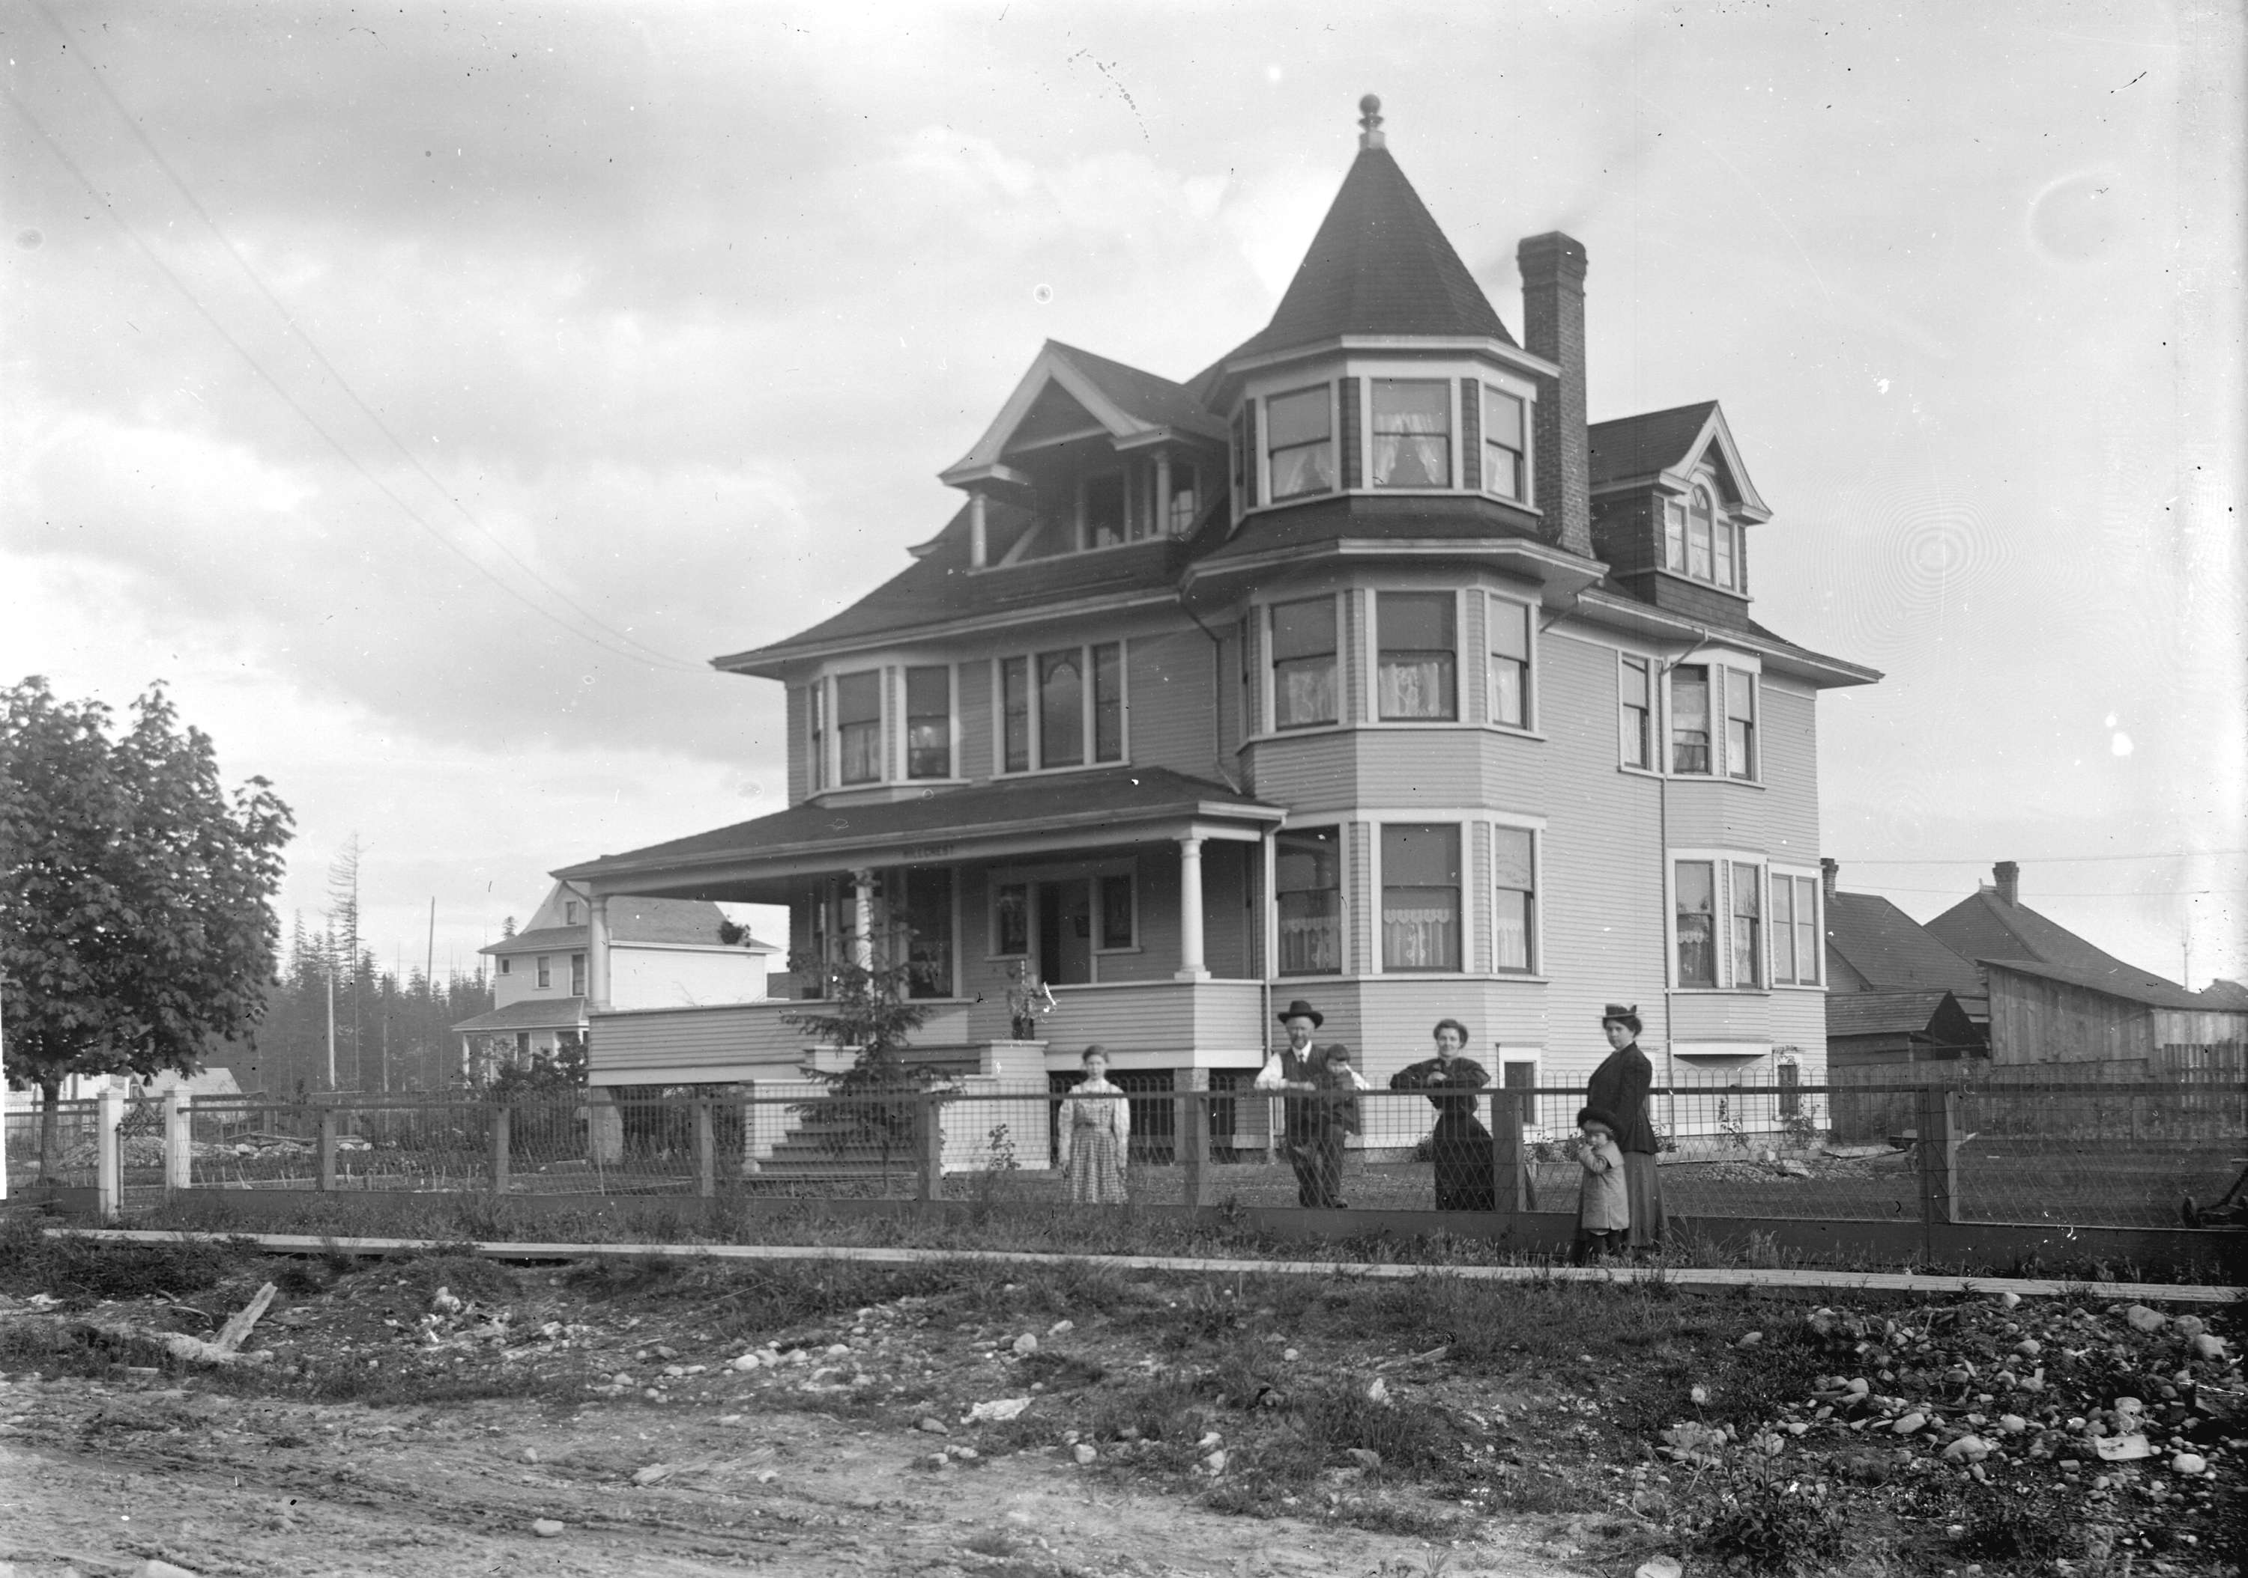

VCA SGN 422 - Professor Edward Odlum residence, 1710 Grant Street; 1900

***City improvements; Street Railway Co.; Painters & Decorators Union; Ship Masters’ Union; Society for Civic Improvements; Stave Lake Power Co.; Vancouver New Westminster Northern and & Yukon Railway; Justice McColl; Mint in Vancouver; Fenton vs Cook and Dixon; Cemetery; tenders; Japanese; smallpox; cinder paths; Salvation Army Shelter; Football Club; Labor Day celebrations; Boys’ Band; School bill; railway from Kootenay to Coast; Ward By-Law: Water Rates and Water Mains By-Law.***

This transcript was made in 2024 by Transcribimus volunteer Joanne McCormick  
Source: City of Vancouver Archives Series 31 (COV S31, 715-D-02)  
Volume 10, pages 73-86

[Volume 10 page] **73**

Vancouver March 11th 1901

The Council met on Monday March 11th 1901.  
Present: His Worship the Mayor and Aldermen Grant, Painter, Neelands, Cook, McPhaiden, Foreman, MacDonald [McDonald], Wood and Fraser.  
The Minutes of last meeting were read and adopted

**Communications**

From J.L. Roberts asking when it was the intention to continue the grading on Harwood Street  
Referred to the Board of Works.

From Messrs Joseph Martin and James F. Garden acknowledging receipt of resolutions re Central Park School etc.  
Matters regarding schools referred to the Finance Committee, balance filed.

From R.G. Tatlow, Chairman of the Park Commissioners asking for $9000 for the current year.

Laid over for Estimates.

From F.R. McD. Russell giving notice of appeal against certain lots.  
Referred to the Finance Committee & City Solicitor.

From A. Kate Pratt asking for the removal of Stumps and logs from in front of her property on Grant Street  
Referred to the Board of Works

From A. Allayne Jones again asking that Stations be considered when consolidation of Street Railway Agreements is discussed  
Referred to the Railway Committee

From E. Tomkins on behalf of the Painters and Decorators Union asking that a By-Law be passed regulating the putting on of wallpaper and Kalsomine [Note: a paint made of slaked lime or chalk]  
Referred to the Finance Committee

From Chas. Kelly and Martin Monney asking for the extension of the sidewalk on ….

[Volume 10 page] **74**

… the South Side of Georgia Street  
Referred to the Board of Works.

From Chas. Moore, Secretary of the Ship Master’s Union thanking the Council for their promptness in placing a light on Granville street Bridge and hoping that Cambie Street Bridge would soon be repaired  
Referred to the Board of Works.

From Clement Reeves of Baraboo, Wis. asking what chance there was for an Orchestra in this City  
Filed

From D.J. Thomas, Springfield, Ohio asking if a Society for Civic Improvements was organized in this City.  
Filed.

From the Metal Stamping Co of Niagara Falls, New York asking if the City wanted anything in the way of street signs, etc.  
Referred to the Board of Works.

From J.R. Jackson asking for a drive way over the sidewalk at Lot 7. Bock 36. DL 302  
Referred to the Board of Works.

From the Police reporting on the electric lights.  
Filed.

From P. Greans applying for a position on the Police Force.

Referred to the Police Committee

From J.B. Ferguson of the Stave Lake Power Co enclosing a Draft of a proposed agreement with the City.  
Moved by Alderman Cook.  
Seconded by Alderman Grant.  
That a special meeting of the City Council be held date to be fixed by the Mayor for the purpose of considering the Stave Lake Power Companys[sic] Agreement and that the representations of the Company be invited to be present.  
Carried

From John Watson etal asking for a sidewalk on Lorne Street  
Referred to the Board of Works

[Volume 10 page] **75**

From F. Gourdeau, Deputy Minister of Marine and Fisheries giving notice that application had been made by Gilbert Bradon for a confirmatory Deed [Note: deed typically used to correct certain defects in record title. The purpose is not to give or create a new title, but simply to "perfect the evidence of a title created long before". from Linkedin.com] to Lot 12. Block 1. O.G.T. [Open Government Title, which refers to a Land Title designation].

Referred to the City Solicitor and Finance Committee

From C.S. Whitehouse asking for the opening up of the Lane in the rear of Lot 10. Block 12. DL 302.  
Referred to the Board of Works.

From E.M. Rhumhash asking for a sidewalk on the North Side of Smythe Street  
Referred to the Board of Works.

From Frank Burnett asking for a road to English Bay  
Referred to the Board of Works

From W.D. Burdis, Secretary of the VNW [Vancouver New Westminster] Northern and Yukon Railway Co. asking that the Delegates that are to be sent by the Council to Victoria endorse the petition of a land grant for the proposed road to the Yukon.  
Moved by Alderman Wood  
Seconded by Alderman Cook,  
That the letter be handed to the Delegates  
Carried

From Chief Justice McColl advising as to Police Investigation  
Referred to the Police Committee

From Frank Burnett asking for a Sidewalk and crossing in front of his residence.  
Referred to the Board of Works

From R.W. Rorison asking the Council to pass the early closing By-Law in relation to hotels and Saloons.

Referred to the Finance Committee.

From His Worship, the Mayor furnishing telegrams that had passed between himself and Mr Maxwell on the Mint question  
Filed

[Volume 10 page] **76**

From the City Solicitor submitting summons served on him in connection with the case of Fenton vs. Cook and Dixon.  
Referred to the Finance Committee

From the City Solicitor stating that the Council had no power to pass a By-Law to close Boot and Shoe stores and Gents Furnishing Stores  
Filed.

The following Reports were received and read:-

**Light Railway and Tramway Committee**

The Light Railway and Tramway Committee met on Tuesday March 5th 1901  
Present: the full Board.

The following accounts were recommended for payment:-

|  |  |  |
| --- | --- | --- |
| B.C. Elec Co. | Lights | $2465.72 |

Communications

From A.A. Jones asking that when the consolidation of leases with the Street Railway Co is considered that the question of providing stations is taken up.

Filed for reference.

From W.A. Fisher etal asking that the new Street railway extension be built on Westminster Road and from I.W. Mills etal asking that it be built on Westminster Avenue.  
Both filed.

From the Police reporting on the Electric lights  
Filed.

From Isaac Russell complaining that cars [streetcar] did not Stop or Signal at Grant Street.  
The General Manager of the Company explained that on occasion referred to the car in question was loaded to its fullest capacity with passengers for the lake on skating bent [sic event] and was a special.

sgd D. McPhaiden  
Chairman

Moved by Alderman McPhaiden  
Seconded by Alderman Wood.  
That the Report be adopted as read.

[Volume 10 page] **77**

Moved in amendment by Alderman McDonald  
Seconded by Alderman Foreman.  
That the clause in reference to proposed extensions on Westminster Av and Westminster Road be referred back to the Committee.  
Amendment carried, motion lost.  
  
Moved by Alderman MacDonald. [sic McDonald]  
Seconded by Alderman Fraser  
That the balance of the Report be adopted.  
Carried

**Health Committee**

The Health Committee met on Wednesday March 6th 1901  
Present: the full Board.

The following accounts were recommended for payment:-

|  |  |  |
| --- | --- | --- |
| Thomson Stat Co. | Supplies | $11.50 |
| J. Dodson | Supplies | 64.80 |
| W. Petite | Labor | 6.00 |
| D.M. Stewart | Washing | 167.87 |
| J.P. Wright | Salary | 48.00 |
| F. Buscombe & Co | Supplies | 3.00 |
| ChS Hack | Supplies | 12.80 |
| Hygiene Creamery | Supplies | 74.79 |
| G. Drysdale | Supplies | 105.60 |
| Trudgeon BrS | Supplies | 218.50 |
| T.B. Cuthbertson & Co | Supplies | 1.00 |
| St Lukes’ Home | Nursing | 14.00 |
| S. Fader & Co. | Supplies | 23.85 |
| Gas Co. | Supplies | 11.45 |
| City Grocery Co. | Supplies | 252.36 |
| Champion & White | Scavengering | 6.00 |
| Mrs Dittrick | Labor | 25.70 |
| Burrard Inlet Meat Co | Supplies | 81.23 |
| White and Hanna | Burials | 78.75 |
| Cleeve Canning Co | Supplies | 6.75 |
| G.A. Roedde | Supplies | 1.75 |
| ThS. Webb | Supplies | 2.00 |
| McDowell & Co | Supplies | 1.00 |
| Industrial Wood Yard | Supplies | 10.45 |
| The Vancouver Agency | Supplies | 88.35 |
| Jas Hughes | Labor | 14.90 |

[Volume 10 page] **78**

Communications

From the Medical Health Officer asking for an increase of Salary  
Laid over for Estimates

From the Crematory Caretaker, Ambulance Contractor and Medical Health Officer furnishing Reports.  
Filed.

From John MacKay etal representing the Hygienic Creamery objecting to carrying on the Milk Contract any longer.  
Filed.

From the Cemetery Caretaker advising that additional property be secured for a cemetery.  
Laid over for Estimates.

From Mrs Mackenzie stating that her son had failed in business as a fish merchant and would not be able to carry out his contract with the City.  
It was resolved that the Contract be awarded to A.M. Tyson the next lowest tenderer.

The tender submitted by Center and Hanna for burials was again laid over.

The following new tenders were received for the supplying of milk:-

|  |  |  |
| --- | --- | --- |
| Valley Dairy Co. | Fresh Milk 22 cts per gallon | Butter Milk 15 cts per gallon |
| Hygienic Creamery | Fresh Milk 23 cts per gallon | Butter Milk 23 cts per gallon |

Resolved that the tender of the Valley Dairy Co be recommend [sic] for acceptance.

The question of scavengering was brought up but was laid over for the Estimates

The City Clerk reported that J. Dodson the successful tenderer on bread refused to furnish more than one bondsman as surety on his contract in addition to himself.  
Resolved that if he does not do so that the Contract be awarded to the next lowest tenderer

[Volume 10 page] **79**

The City Clerk reported that Japanese treated in the hospital were indebted to the City to the extent of $605 during the past year.  
The matter was laid over until it can be ascertained how this amount can be collected.

The Health Inspector furnished a report and stated therein that he had failed to collect from two small pox patients treated in the Isolation Hospital.  
It was resolved that the account be handed to the City Auditor for collection

sgd. W.J. McGuigan  
Chairman  
  
Moved by Alderman Foreman  
Seconded by Alderman Grant  
That the Report be adopted  
Carried

**Board of Works**

The Board of Works met on Thursday  
Present: the full Board.

A deputation from the Good Roads Association waited on the Board and submitted the following recommendations as to the location of proposed cinder paths:--  
Pender Street from Post Office to Georgia St  
Westminster Av from Harris Street to Band Stand, Mount Pleasant.  
Granville Street from Robson Street to the Bridge  
Beach Avenue where not mackadamized [macadamized] from Burnaby Street to Burrard.  
Moved by Alderman Cook.  
That the location of paths as submitted by the Association be adopted and that Powell Street be the next track when the present programme is finished  
The motion was carried on the casting vote of the Chairman

S. Elkins Sewer Inspector reported as to the blind connection made on Seaton Street with the new Sewer.  
The matter was laid over.

Communications

Re the petition of Dunlop referred by [sic] to the Board by the Council it was resolved ….

[Volume 10 page] **80**

…. that he be informed that it is not the wish of the City to lease any portion of the Streets.

From WD. McLean re stones left in lane by Sewer contractor at the back of 850 Harris Street  
Contractor to be notified to remove the same at once.

From J. Mason requesting that stumps be removed from road between Blocks 54 and 55 264A  
Referred to Alderman McDonald and the City Engineer to report.

From G.M. Charlton etal requesting that walk on 3rd Avenue Fairview from Maple to Arbutus Street be made one plank wider and 3 plank walk be continued from Arbutus to Yew Street.

From B.B. Johnson & Co. requesting new walk at the NW corner of Granville and Georgia Streets.

From C.H. Wilson etal requesting that Nelson Street be graded West from Denman Street.

From Webster BrS. requesting walk on Drake Street for one block between Hornby and Burrard Street and crossing

From J.G. Johnson asking that Pendrell Street be opened from Bute to Jervis Street

From H. Graham etal petitioning for stone culvert to be put in on 8th Ave Mt Pleasant.

These were all laid over for the Estimates

From Tom Wilson re water flooding on to his lot at corner of 9th Av and Spence Street  
Engineer to enquire into and report.

From W.M. Loree etal asking for the opening of 6th Av from Granville Street west to Fir Street and sidewalk laid down.  
Laid over for the present

From J. Nesbit re extension of Sewers on Pacific Street.  
The Sewer is being extended

[Volume 10 page] **81**

Crossing was ordered to be put down on Westminster Avenue at the first car stop south of the bridge

The Engineer was instructed to report on application of C. Olmstead for payment for work done on 9th Av East.

The following accounts were recommended for payment:-

|  |  |  |
| --- | --- | --- |
| Roberson & Hackett | Supplies | $30.75 |
| Hastings Saw Mill | Supplies | 18.64 |
| Vancouver City Iron Works | Supplies | 123.61 |

sgd Robert Grant  
Chairman  
  
Moved by Alderman Grant.  
Seconded by Alderman Cook.  
That the Report be adopted  
  
Moved in Amendment by Alderman McPhaiden  
Seconded by Alderman Fraser.  
That the proposed cinder paths be added to to [sic] include Powell Street  
  
Moved as amendment to Amendment by Alderman MacDonald [sic]  
Seconded by Alderman Foreman.  
That the works “Powell Street” in the cinder path clause be amended to read east end.  
  
Amendment to amendment carried. Amendment lost; motion not past.

Moved by Alderman McDonald  
Seconded by Alderman Fraser.  
That the Report as amended be adopted.  
Carried.

**Finance Committee**

The Finance Committee met on March 8th 1901  
Present Aldermen Neelands, Painter and Fraser.

Adjutant Hay of the Salvation Army Shelter interviewee the Board and asked for exemption of the Taxes on the shelter  
Resolved that the Salvation Army be granted a rebate of their taxes on the shelter

Mr A.K.H. Macfarlane waited on the Board …

[Volume 10 page] **82**

… and asked for a grant for the Association Football Club.  
The matter was laid over for the Estimates.

Communications

From S.D. Childs & Co. offering to supply the City with a new seal for $15.00  
Filed.

From J.H. Cronshaw asking for a grant in aid of the Boys’ Band.  
Laid over for the Estimates.

From J.C. Marshall, Secretary of the Trades and Labor Council asking for a grant in aid of Labor Day Celebration.  
Laid over for the Estimates

W.J. Trythall’s account for $64800 for 450 copies of the City Charter was referred to the Chairman to investigate.

The following Contract was authorized to be signed by the Mayor and City Clerk and the Corporate Seal affixed thereto if found satisfactory by the City Solicitor.  
Welsh and Nightingale Groceries

The following accounts were recommended for payment:-

|  |  |  |
| --- | --- | --- |
| City Grocery Co. | Supplies | $1.50 |
| B.C. Toilet Supply Co. | Supplies | 1.50 |
| McLennan & McFeely | Supplies | .65 |
| ThS. Dunn & Co. | Supplies | 2.35 |
| F.A. Lee | Hacks | 3.00 |
| A. St G. Hamersley | Disbursements | 58.60 |
| Thomson St Co | Supplies | 28.24 |
| G.A. Roedde | Supplies | 18.00 |
| Evans Coleman & Evans | Supplies | 25.36 |
| C.P.R. Co. Telegraph | Telegrams | 4.47 |
| Telephone Co. | Rents | 48.41 |
| Roberson BrS. | Insurance | 30.00 |
| Mahon, McFarlane & Mohore | Insurance | 30.00 |

sgd T.F. Neelands  
Chairman  
  
Moved by Alderman Neelands  
Seconded by Alderman Fraser.  
That the Report be adopted  
Carried

[Volume 10 page] **83**

**Motions**

Moved by Alderman Neelands  
Seconded by Alderman Foreman.  
That the following account be paid:-

|  |  |  |
| --- | --- | --- |
| M.O.M. Coray | Chimney Sweeping | $6.00 |

Moved by Alderman Neelands  
Seconded by Alderman Wood  
  
Whereas the whole expenses of providing for the primary education as well as the expenses and cost of the High School are now borne and paid by the City, the only subsidy in aid thereof granted by the Government being the per capita grant of $10.00 per head, amounting to $33,000 per annum, and the Revenue hitherto derived from the Poll Tax of $15,000 per annum making in all $48,000 per annum.  
And Whereas at present the burden of expense now borne by the City to defray the cost of education is $100,424.50 per annum being made up of the amount payable for interest and sinking fund on the debenture debt incurred for building Schools and acquiring sites, and $85,560 per annum for cost of salaries and maintenance thus making a tax of over 4 mills on the dollar on the assessed value on all real property in the City  
And Whereas a Bill to amend the School Act is now before the Legislature and other measures it is believed will be introduce during the current Session of the House of Representatives affecting the income and grants hitherto received by the City from the Province as a contribution towards the expenditure on education in the City  
And Whereas under the provisions of the proposed legislation the income derived by the City from the Province in aid of the Schools, now i.e., only $48,000 per annum, will be further reduced by a sum of $3,600 per annum  
And Whereas the Bill now before the House also provides that the Board of School Trustees can force the Council …

[Volume 10 page] **84**

… of the City at any time to submit a By-Law to the vote of the citizens to provide further sums for erecting Schools and increasing the debenture debt of the City notwithstanding what the financial position of the City may be;  
Be it therefore resolved that this Council protests against Section 14 of the said Bill becoming law as the effect thereof, if passed, would place a further change on the City in respect of education, the amount of which is at present excessive and also would make it compulsory on the Council to submit By-Laws increasing the debenture debt of the City and thus prevent the City providing funds for other necessary works and wants.  
And be it further resolved that a deputation of the Council consisting of His Worship and Aldermen Neelands and Fraser, attend at Victoria to bring the above resolution before the Government and urge that the income received from the Province in aid of education be not reduced but increased as absolutely necessary in the interests of the City;  
And, also that the per capita grant referred to in Section 11 of the said Act be increased from $13.00 to $15.00  
And that the Revenue tax commonly known as the Poll Tax be paid to the City as heretofore and not to the Province  
And that a copy of this resolution be forwarded to each member for Vancouver with a request that he will oppose the passing of the said Section.’’[sic]  
Carried.

Moved by Alderman Cook.  
Seconded by Alderman Fraser.  
Resolved that the Vancouver City Council respectfully ask the Legislature of this Province to grant a subsidy for the construction of a Railway from the Kootenay to the Coast to such as Company as shall demonstrate to the satisfaction of the Legislature its capability to proceed at once with the construction of such a Railway …

[Volume 10 page] **85**

… and to build not less than 150 miles a year until its completion  
And that the Legislature be asked to retain such control over the freight and passengers [sic] rates as shall fully protect the inhabitants of this Province[.] It is specially recommended that any Railway Company receiving a subsidy shall be an independent line and that it shall be built from Vancouver and Coast points eastward through Chilliwack during 1911’’ [sic] Carried.

Moved by Alderman Fraser  
Seconded by Alderman Cook.  
Whereas the gold output for the Yukon District and British Columbia for the year 1899 amounted to $20,202,473 and the gold product of all the remainder of Canada was but $1,057,964 during the same period; or in other words the gold product of British Columbia and the Yukon amounted to more than nineteen times as much as that of all the rest of Canada combined, and during the year 1900 at least $4,000,000 making the yield at present more than twenty two times as great as that of the East, and  
Whereas the location of the Mint in this City would vastly increase the trade of British Columbia and the West of Canada, inasmuch as the gold is now being taken to the American Sound Cities, and the trade as a consequence is being diverted from Canadian to American Cities;  
Therefore, be it resolved that the Vancouver City Council do hereby strongly urge the Dominion Government to locate the Mint here, and further that a copy of this resolution be sent by wire to each of the following named members of the Government:-  
Sir Wilfred Laurier, Hon. Mr Fielding, and Hon Mr Sifton’’ [sic]  
Carried.

[Volume 10 page] **86**

**Consideration of By-Laws**

Moved by Alderman Foreman  
Seconded by Alderman Neelands  
That the By-Law to divide the City into Wards be read a second time.   
Carried  
  
The By-Law was accordingly read a second time

**Notice of Motion**

Alderman Painter gave notice that at the next meeting of the Council, he would introduce a By-Law to amend By-Laws 361 and 362 governing Water Rates and Water Mains.

The Council then adjourned.

T. Townley  
Mayor

ThS. F. McGuigan  
City Clerk