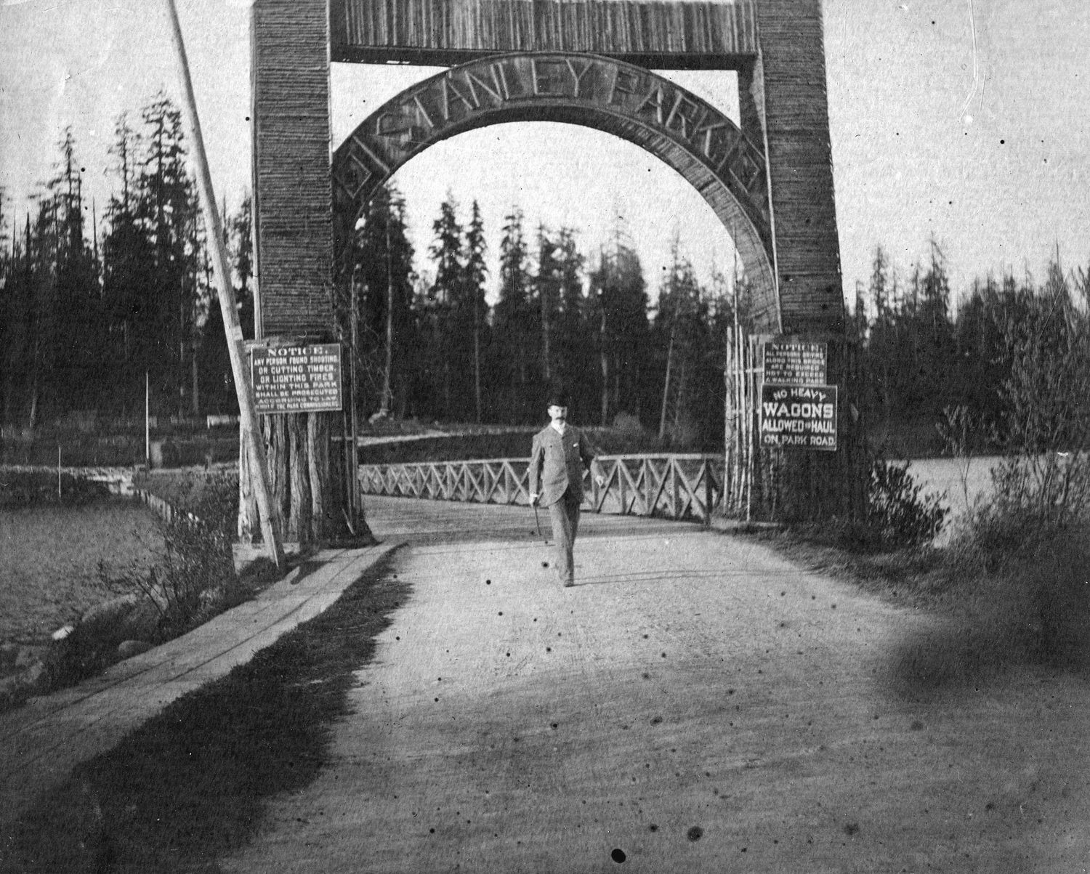
1895-1910 – Entrance arch
Photo from City of Vancouver Archives https://vancouverguardian.com/vintage-photographs-stanley-park/

Friendly Aid Society; Vancouver New Westminster, Northern and Yukon Railway Company; Stanley Park entrance; Sanitary Inspector; Dr. J.A. L. M^{c}Alpine; Lady Aberdeen’s Victorian Nurses; Tasmanian collection; Ward By-Law;

This transcript was made in July 2025 by Transcribimus volunteers Lisa Thorson and
Gerald Soon.
Source: City of Vancouver Archives, Series 31, (COV-531, 715-D-02)
Volume 10, pages 409-414

[Volume 10 page] 409

Vancouver Dec 9 1901

The Council met on Dec 9th 1901
Present His Worship the Mayor and Aldermen Cook, Neelands, M^{c}Guigan, M^{c}Phaiden, Foreman Wood and Wylie
The minutes of last meeting were adopted as read.
Communications
From J.W Deptford complaining of Box Drain flooding his premises.
Referred to the Board of Works.

From J.W. M^{c}Intosh reporting re Street lights.
Referred to Police Committee.

From A.N Tregent re grade on Campbell Avenue and Hastings Street
Referred to Board of Works.

From Mrs McCauley asking that three Aldermen be appointed to represent the Council on the Friendly Aid Society.
Resolved that Aldermen Wood, Neelands and M^{c}Phaiden be appointed representatives from the Council.

From W.S. Ashworth re drain flooding his property on Vernon St.
Referred to Board of Works.

The following reports were received and read:-
Light Railway
The Light Railway and Tramway Committee met on Tuesday, Dec 3rd, 1901
Present Aldermen M^{c}Phaiden Neelands Freeman and Wood.
The minutes of last meeting adopted as read.

Several applications for lights were received but it was decided not to place any more this year.

The City Solicitor was instructed to put in clause in Mrs Marshall’s lease providing …

[Volume 10 page] 410

… for the construction of a waiting room on Lot at the entrance to Stanley Park.
A deputation from the representatives of the Vancouver, New Westminster Northern and Yukon Railway Company waited upon the Board.
Moved by Alderman Wood
Whereas considerable and unforeseen difficulties have presented themselves in respect to the location of the most feasible routes for the company into this City and one which will be most acceptable to the citizens and to the Vancouver Westminster and Yukon Railway whereby delay in formulating a proposition for submission to this Committee has been unavoidable this Committee after hearing the explanations made by the Secy, Mr W.D. Burdis and Mr J. Jeffrey believing that the expressed intention of this Company immediately to construct this the first section of its road if reasonable facilities and encouragement are offered and recognizing that this road when constructed will be highly beneficial to Vancouver heartily recommends the City Council to endorse the general principles of the application made by the Company on the 27th of August 1901 and asks the incoming Council to accord its most favourable consideration to the detailed proposition shortly to be introduced.
Carried.

The following account was recommended for payment.
B.C. Elec Co | $2511.19

The Board then adjourned.
Moved by Ald. M^{c}Phaiden
Seconded by Ald. Wood
That the report be adopted as read
Carried

Health
The Health Committee met on Wednesday Dec 4, 1901
Present Aldermen McGuigan Neelands and Wylie

[Volume 10 page] 411

The minutes of last meeting were adopted as read.

Communications
From the Medical Health Officer and Crematory Caretaker furnishing reports.
Filed.

From the Medical Health Officer asking to be appointed Sanitary Inspector
Resolved that Robt Manion be appointed Sanitary Inspector in accordance with the requirements of the Health Act.
Resolved that the Caretaker of the Cemetery be authorized to hire temporarily a horse and cart to clear of rubbish.
Resolved that Dr J. A .L. McAlpine be appointed a member of the Hospital Medical Staff.

Resolved that Nurse Hill shall have her board gratis at the City Hospital she being on Lady Aberdeen’s Victorian Nurses.

The following accounts were recommended for payment:-
Wm Crook | 2.00
Trudgeon Bros | 84.24
G Drysdale | 5.10
Clewe Canning Co. | 14.25
Thos Dunn | 11.90
Welsh & Nightingale | 284.23
Champion & White | 8.00
W.L. Tait | 3.24
F.A. Lee | 4.00
C. Hack | 5.00
Hastings Mill | 3.69
H. Kersey | 8.40
Knowdell & Hodgson | 15.00
W.H. M^{c}Morran | 2.00

The Board then adjourned.
Moved by Ald, M^{c}Guigan
Seconded by Ald. Neelands
That the report be adopted as read.
Carried.

Board of Works
The Board of works met on Dec 5, 1901
Present Ald. Cook, M^{c}Phaiden, and Wood

[Volume 10 page] 412

Moved by Ald. M^{c}Phaiden
That Ald. Cook take the Chair.
Carried.

The minutes of last meeting were adopted as read.

Communications
From R. Robinson et al asking for a walk and the grading of Cardero Street from Georgia to Barclay.
Referred to next years [sic]Council.

From S. Harris re his employment at new Cemetery and from the Foreman on same
Filed.

From A.C. Brydon Jack re condition of Pender Street Bicycle Path.
Referred to Engineer to see Mr Buntzen.
From G.M. Johnson asking for the opening of lane between 8th and 9th Ave. East to Scott Street.
To be notified that the City has no lane registered.

From Ross and Howard asking for walk on North side of Powell Street from Barnard Castle to Sugar Refinery
Referred to next year’s Council.

From Webster Bros re the giving of work to Mr Tolley
Referred to Engineer.

From E. Odlum and J. J. Banfield re the widening of Westminster Avenue
Engineer to report as to cost of moving Buildings.

Mr Kilmer, Asst Engineer reported the claim of Dixon and Cook for non-delivery of pipe at East End Sewer.
Referred to Engineer to consult with City Solicitor and report next week.

It was. recommended that the City Solicitor write the Marine Dept. at Ottawa stating that the City desire to open Keefer Street and do not wish to be hampered when putting a Street Through.

[Volume 10 page] 413

The following accounts were passed for payment:-
M. Urquhart | 3.25
M^{c}Donald Bros | 23.85
Pacific Transfer Co. | 1.65
F. Boller | 10.60
M^{c}Donald Bros | 748.39
Robertson & Hackett | 60.72
B.C. Mills | 24.22
Hastings Saw Mill | 102.53
W.L. Tait | 59.28
W.S. Hurst | 1571.40

The Board then adjourned.
Moved by Ald. Cook
Seconded by Ald. M^{c}Phaiden
That the report be adopted as read.
Carried.

Finance
The Finance Committee met on Friday Dec. 6th, 1901.
Present Aldermen Neelands, McGuigan and Wylie.
The minutes of the last meeting were read and adopted.

The following accounts were recommended for payment:-
The Province | 408.80
The World | 407.08
The News Ad. | 425.20
W.E. Graveley | 35.00
Clarke & Stuart | 10.95
Timms & Co. | 630.50
B. C. Toilet Col | 1.50
M. Urquhart | 5.00
B C Elec Co | [amount not indicated]

Communications
From the Vancouver Transfer Co. objecting to the fees allowed by the City for drayage.
Filed.

From John Pugh offering to mount the Tasmanian collection of birds and animals for $90.00
Resolved that his offer be accepted.

From A. P Horne and Hobson & Co. applying for the insurance on Water Works building on Alexander Street …

[Volume 10 page] 414

… Resolved that the insurance be placed with Hobson & Co.

From C. Goodmurphy offering $200.00 for G[?] on 8th Ave Mt Pleasant.
Laid over for inquiries.

The Board then adjourned.
Moved by Alderman Neelands
Seconded by Alderman M^{c}Guigan
That the report be adopted as read
Carried.

Consideration of By-Laws
Moved by Ald. Neelands
Seconded by Ald. Wood
That the Ward By-Law be read a 2nd time
Carried

The Council then adjourned.

T. O. Townley
Mayor
ThS. F. McGuigan
City Clerk

