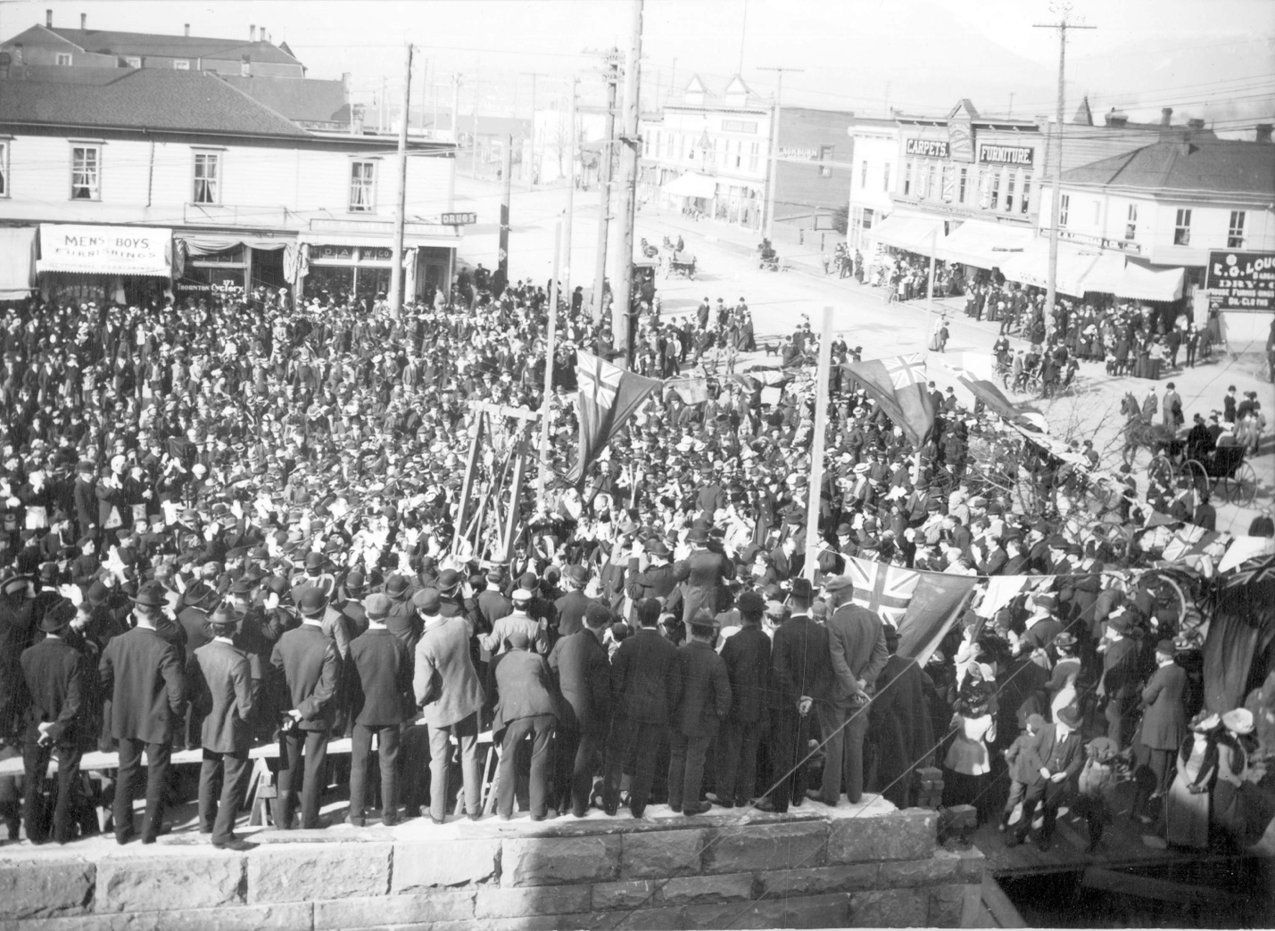

Cornerstone ceremony at Vancouver Free (Carnegie) Library - S.W. Corner of Westminster Avenue (Main Street) and Hastings Street.
COV - AM54-S4-: Bu P272

Free Library; sandwich cart; B.C. Electric; fire alarm box; Curator position; street numbering; Market site; Park Commissioners; Captain Williams.

This transcript was made in November 2025 by Transcribimus volunteer Lynn Shane.
Source: City of Vancouver Archives, Series 31 (COV-531, 715-D-02)
Volume 10, pages 370 – 374.

[Volume 10 page] 370

Vancouver November 4th 1901.

The Council met on Monday Nov 4th 1901.
Present: His Worship, the Mayor, and Aldermen Grant, Neelands, McGuigan, McPhaiden, Foreman and Wylie.

The Minutes of last meeting were read and adopted.

Communications

From the City Solicitor Stating that the Government had consented to amend the By-Law authorizing the erection of a library on Lots 1, 2 & 3 in Block 10 D.L. 196.
Filed.

From Alderman Grant asking for leave of absence for the balance of his term.
Moved by Alderman Neelands
Seconded by Alderman Foreman.
That the request be granted
Carried

From P.A. Farline asking for permission to run a Sandwich cart at the corner of Hastings and Carrall Streets
Referred to the Police Committee

From the Vancouver Property Owners and the Manager of the B.C. Electric Co. complaining of the grading and cutting of Hastings Street near Campbell Av.
Referred to the Board of Works

From G. Stevens etal asking for ditching on 7th Av Fairview
Referred to the Board of Works.

From C.H. Cates asking for the settlement of his account for cribbing [Note: A temporary framework of interlocking wood beams or blocks used to support heavy loads.] at the foot of Heatley Av.
Referred to the Board of Works.

From Mrs H. Guitzburger etal calling attention to the fearful condition of the lane in rear of 530 Burrard St.
Referred to the Board of Works.

From E.H. Heaps & Co. asking for a fire alarm box at Cedar Cove Powell St.
Referred to the Light Fire Committee.

[Volume 10 page] 371

From A.G. Alcock applying for a position in connection with the renumbering of the City.
Referred to the Board of Works

From W^{m} Murray etal asking for the opening up of 15th Ave.
Referred to the Board of Works.

From Geo. S.D. Perry Assistant Secretary of the School Board asking for an amendment to the Health By-Law.
Referred to the Health Committee

From Abel Heine applying for the position of Curator.
Filed.

From the Police Court Clerk reporting on the Electric Lights.
Filed.

From J. N. Sinclair etal complaining about the irregular street numbering
Referred to the Board of Works

The following Reports were received and read:-

Board of Works

The Board of Works met on Thursday at 4 P.M.
Present: Aldermen Grant, Cook, McPhaiden and Wood.

Communications
From W.W. McGuire re extending Sewer to Lot 17 Block 26. 200a.
Engineer to see if lot is within 100 feet.

From the City Solicitor with reference to the resurvey of 264A
Resolved that the Solicitor be empowered to proceed with the necessary steps according to his letter for the resurvey of 264A

From Geo Underwood asking that stumps and Stones be cleared from the corner of 5th Av and Arbutus Streets
Engineer to examine and report.

From R.A. McCullough etal petitioning for 6 ft. walk on Westminster Road from 9th Av …

[Volume 10 page] 372

… to 12th Avenue east side.
Referred to the favorable consideration of next years [sic] Council.

From D. Brockwell asking that lane in rear of Block 46 corner of Manitoba Street and 7th Av. be opened
Engineer to examine and report.

From R. McLeod asking that Council will move out walk in front of Lot 14. Block 42. Howe Street.
Engineer to examine and report.

The following accounts were recommended for payment:
Geo Hardy | Express | 50 cts
ThS. Clough | Supplies | $1.50
ThS. Veitch | Drayage | 270.00
W.L. Tait | Supplies | 47.20
S. Hallander | Supplies | 7.00
T. O’Connor | Supplies | 10.50
B.C. Mills | Supplies | 52.61
Hastings Mill | Supplies | 201.31
McDonald BrS. | Teaming | 328.00
J. Williams | Rock | 809.00

sgd Robt. Grant
Chairman

Moved by Alderman Grant
Seconded by Alderman McPhaiden
That the Report be adopted
Carried.

Finance Committee

The Finance Committee met on Friday November 1st 1901.
Present: Alderman Neelands, Foreman and Wylie

The following accounts were recommended for payment:-
J.J. Woods | Salary | $67.50
F.T. Cope | Grant: Band | 75.00
D.C. Lew | Interpreting | $6.00

Communications
From the Park Commissioners asking for an overdraft of $400
Resolved that provision be made for the payment of salaries and …

[Volume 10 page] 373

.. for feed for the animals and birds and that all work be laid over.

From J.A M^{c}Nair and John McDonald asking that the City to retain for them all monies due or are coming due to Capt. Williams
Referred to City Solicitor.

Sgd
ThS. F. Neelands
Chairman
Moved by Alderman Neelands
Seconded by Alderman McGuigan
That the Report be adopted with the amendment that the Park Commissioners be granted $400
Carried.

Introduction of By-Laws
Moved by Alderman Foreman
Seconded by Alderman McPhaiden
That a By-Law be introduced to appropriate a portion of the site known as the Market Site for the purposes of a public library
Carried
The By-Law was accordingly read a first time.

Motions
Moved by Alderman Neelands
Seconded by Alderman Foreman
That the Report of the Joint Committee of the City Council and the Free Library Board recommending the acceptance of the plans of M^{r} G.W. Grant for the Free Library and the awarding of the contract for the construction thereof to Albert Adams be adopted by this Council.
Carried.

Consideration of By-Laws
Moved by Alderman Foreman
Seconded by Alderman McPhaiden
That the Free Library By-Law Site be read a second time
Carried

[Volume 10 page] 374

The By-Law was accordingly read a second time
The Council went into Committee of the Whole for its consideration with Alderman Foreman in the Chair.
The By-Law was read over clause by clause and reported to Council as complete.
The Rules were suspended and the By-Law read a 3rd time on Motion of Alderman Foreman
Seconded by Alderman McPhaiden.

The Council then adjourned

[sgd] T.O. Townley
Mayor
ThS. F. McGuigan
City Clerk

