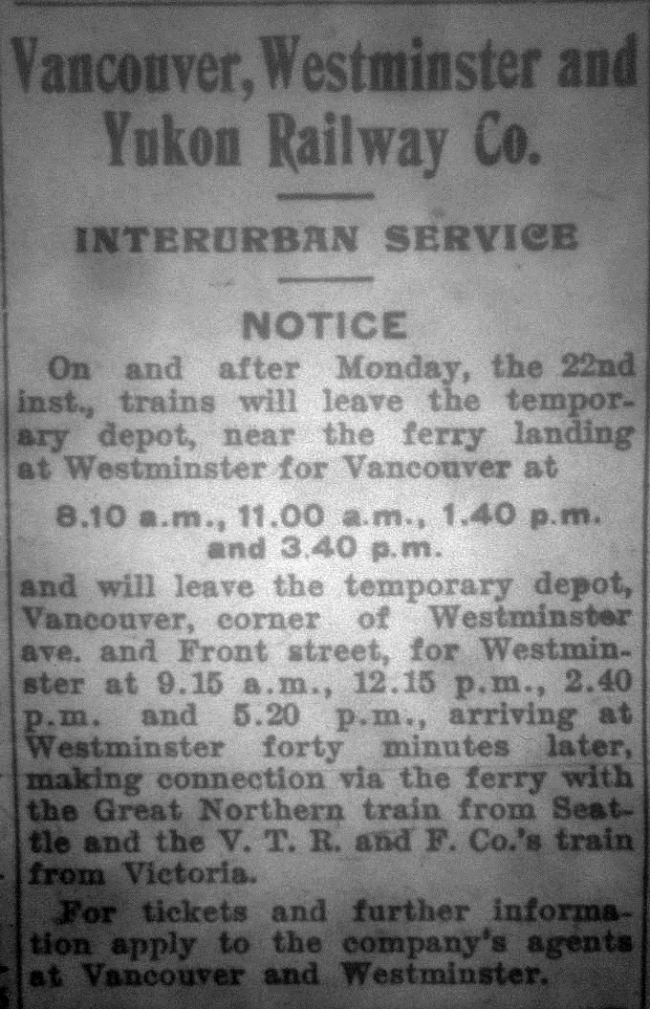
1904 Notice Vancouver, Westminster and Yukon Railway Co.
https://oppositethecity.wordpress.com/2014/03/18/the-vwy-ry-1904-an-interurban-service/

Foreshore rights; Dr. Poole; health certificates for children; secret societies in public cemetery;Tasmanian animals; cemetary insurance co.; shipping to Northern Territories; ward by-law; Vancouver, Westminster and Yukon Railway Co.

This transcript was made in June 2025 by Transcribimus volunteer Barbara Kearney-Copan.
Source: City of Vancouver Archives, Series 31 (COV-531, 715-D-02)
Volume 10, pages 391-399

[Volume 10 page] 391

Vancouver November 25th 1901.

The Council met on Monday November 25,1901.
Present His Worship the Mayor and Aldermen Painter, Cook, Neelands, McPhaiden, McGuigan, Foreman, MacDonald, Wood and Wylie
The Minutes of last meetings were read and adopted.

Communications
From the City Auditor reporting on the first of July Celebration accounts.
The Mayor promised to call a meeting of the Committee who had the matter in hand

From J.A. Lester, Secretary of the Firemens [sic] Benefit Association furnishing copies of Souvenir numbers
Accepted with thanks

From Police Court Clerk reporting on Street lights.
Referred to Light Committee.

From W.S. Gore acknowledging receipt of resolution re foreshore of False Creek.
Filed.

From McDonnell & Simpson asking for the use of the City Hall for a Benefit Matinee on 30th inst.
Referred to Market Clerk with power to act.

From Mr England, Secy Gas Works asking that no action be taken on the application of Mr Magee for Foreshore rights.
Referred to Board of Works.

From W.L. Stringer et al petitioning for an electric light Corner of 5th Ave and Arbutus Street
Referred to Light Committee.

From the Vancouver Property Owners Assoc. re grading on Hastings St and Campbell Avenue
Referred to Board of Works.

[Volume 10 page] 392

From Mrs T.M. Maclean thanking Dr Poole Acting M.H.O. for kindness since the death of her husband.
Moved by Ald McGuigan
Seconded by Ald Wood
That the thanks of this Council is tendered to Dr Poole for his services as Medical Health Officer for the past two months.
Carried.

From G.W. Grant, Architect asking that 5 feet be allowed between the new Library Building and
Hastings Street line
Moved by Ald Cook
Seconded by Ald McGuigan
That Mr Grant’s request be granted
Carried.

From Ivan Bushony protesting against the purchase of a safe without tenders being called for
Referred to Health Committee

From J. Buntzen, Gen Man B.C Elec Co. agreeing to pay ½ cost of relaying rails where necessitated by change of grade on Campbell Ave and Hastings Street.
Moved by Ald Cook
Seconded by Ald McDonald [sic]
That the Communication be referred to the Engineer with power to act
Carried.

Reports
The following reports were reviewed and read:
Health
The Health Committee met on Wednesday, Nov. 20th, 1901
Present Ald. McGuigan, Neelands, Foreman and Wylie.
The minutes of the last meeting were read and adopted.

Communications
From the School Board asking for …

[Volume 10 page] 393

… an amendment to the Health By-Law compelling the issuing of Health Certificates before children who suffered from infectious diseases are allowed to attend school
Resolved that the required amendment be made

From J.L. Purser stating that there was no stretcher with the ambulance when the accident occurred to Mr Ramage
Filed.

From Fred Cockburn on behalf of the I.O.O.F. [Independent Order of Odd Fellows] asking for a plot in the Public Cemetery
Resolved that a piece of land not exceeding 6 plots be set aside in the Public Cemetery from each Secret Society requiring same

The Committee again refused to recommend the payment of the safe for the City Hospital.

The following accounts were recommended for payment:-
Champion and White | 1.00
Central Fish Market | 19.15
Miss Clenden[n]ing | 3.00
Thos Dunn & Co. | 67.14
Hinton Elec Co. | 5.00
F A Lee | 1.50
M. Lee | 4.00
Fader & Co. | 154.65
Evans, Coleman & Evans | 69.30
Mrs Smith | 15.00
Gas Co. | 18.60
Valley Dairy | 142.61
Welsh & Nightingale | 267.72

The Board then adjourned.
Moved by Ald McGuigan
Seconded by Ald MacDonald
That the report be adopted as read and that an account from C.G. Johnson for $183 for a safe for the City Hospital, be passed for payment
Carried.

[Volume 10 page] 394

Board of Works
The Board of Works met on Nov. 21st, 1901
Present Ald. Cook, McPhaiden, MacDonald and Wood.
It was moved by Ald. McPhaiden
That Ald. Cook take the Chair
Carried.
The minutes of last meeting were read and adopted.

Mr Deacon appeared re foreshore application of Mr Magee
It was decided that the Council meet at 11 a.m. on Monday and inspect the foreshore in question

Communication
From A.E. Coffin asking for culvert outlet on Prior Street so as to prevent flooding of his lot.
Work already ordered.

From Dixon and Cook claiming $1205 for delay in delivery of pipe on East End Sewers.
Engineer to report.

From C.F. Hilton asking for 3 plank walk and crossing on East Side of Cedar Street, about 250 feet.
Walk to be laid.

From Chas. E. Goad offering correction Slips for insurance map for $31.20
Referred to incoming Council.

From W.W. McGuire asking for sewer in Block 26, 200a
Referred to Engineer to attend to.

From E.C. Dixon re condition of Campbell Avenue and Hastings Street
Street being put in condition as rapidly as possible.

From Wm. Harris et al asking for the opening of Cedar Street from 3rd to 4th Avenue
Engineer to report at next meeting.

[Volume 10 page] 395

From G. Caimourea asking for the opening of road to Block 9, D.L. 192.
Referred to Engineer.

From M.F. Blackwell etal re dangerous fir trees on Lot 2, Block 53, 185
To be informed that they must notify owner of property.

From A.E. Carter asking for permission to move building along Dunlevy Avenue.
Permission granted provided he puts up usual deposit

From W. Creighton re completion of walk on South Side of Alberni Street from Broughton to Nicola
Will be attended to.

Alderman Cook and the Engineer were appointed to interview Mr. Buntzen re Campbell Ave track.

The following accounts were recommended for payment:-
B.C. M. T & T. Co. | Supplies | $11.06
W.L. Tait | Supplies | 308.59
Geo H. Blair | Supplies | 17.50
Champion & White | Supplies | 11.25
Pacific Transfer Co. | Teaming | 4.00
ThS. Dunn & Co. | Supplies | 178.58

sgd E. Cook
Acting Chairman
Moved by Alderman Wood
Seconded by Alderman McPhaiden
That the Report be adopted
Carried

Finance Committee
The Finance Committee met on Friday November 22, 1901.
Present Aldermen Neelands, McGuigan, Foreman and Wylie

The following accounts were recommended for payment:-
G.W. Chadsey | Taxes | $14.95
Bank of Commerce | Deeds etc | 15.00
Hunt and Foster | Supplies | 340.00

[Volume 10 page] 396

Communications
From the City Auditor furnishing report on 1st of July accounts.
Referred to the Council

From Mr Pugh asking for the contract for mounting the birds and animals received from Tasmania
He was requested to send statement of cost.

Mrs Marshall’s application for renewal of base was again laid over.

Mr C.A. Lett asked the Committee to subscribe for shares in the Cemetery Insurace Co.
Laid over for one week.

Mr Young asked for rebate on back taxes
Request refused.

sgd T.F. Neelands
Chairman
Moved by Alderman Neelands
Seconded by Alderman Foreman
That the Report be adopted
Carried

Motions
Moved by Alderman Cook
Seconded By Alderman Neelands
That the following accounts be paid:-
Jas Pearson | Wages | $33.25

Moved by Alderman McPhaiden
Seconded by Alderman Wylie
Whereas the development of the Northern Territories on the Pacific Coast having assumed such proportions and being constantly increasing it has become necessary in order to obtain the full benefit of the trade thereof for Canada to which it properly belongs that sufficient shipping accommodation should be provided.
And whereas a large number of ships heavily subsidized by the American Government are now employed in this trade …

[Volume 10 page] 397

… running from the Pacific Coast Ports in American Territory and thereby diverting the business
from its proper and legitimate channels.
And whereas in order to prevent the continuance of such a state of affairs that is so detrimental to the commercial interests of Canada it is the opinion of this Council that it is necessary and advisable that a subsidy should be granted to British Ships now trading from Canadian Ports to the said Northern Territories in order to place them on an equal footing with the ships so trading from American Ports.
And whereas the Council is of the opinion that unless such a subsidy is granted the interests of Canadian Ports and trade must be seriously affected.
Be it therefore resolved that the Government of the Dominion be respectfully requested to grant such aid or subsidy as may be necessary in order to foster and establish the trade of British Ships between Canadian Ports and the North Pacific Coast and thus enable such ships to successfully compete with the at present subsidized American Ships.
And that a copy of this resolution be forwarded to G.R. Maxwell M.P. Member for Burrard with a request that he will use his influence to accomplish the objects of the foregoing resolution
Carried

Moved by Alderman McGuigan
Seconded by Alderman Wood
That the thanks of this Council be tendered Dr Poole for his services as Medical Health Officer for the past two months
Carried

Moved by AldermanCook
Seconded by Alderman Neelands
That hereafter before proceeding with changes of grade of the City Streets the City Engineer first make a report to the Board of Works of the cost and described the proposed works this to be approved …

[Volume 10 page] 398

… by the Council before proceeding.
This shall apply to all works included in general work appropriations unless the cuttings are under one foot in depth and no objection made by land owners fronting on the street affected.
Carried.

Introduction of By-Laws
Moved by Alderman Cook
Seconded by Alderman Neelands
That a By-Law to raise by way of Debentures the sum of $25000 for the purchase and improvement of the Cambie Street grounds be read a first time.
Carried
The By-Law was accordingly read a first time.

Moved by Alderman McGuigan
Seconded by Alderman Foreman
That a By-Law to raise by way of Debentures the sum of $5500 for the purchase of a hospital
site be read a first time.
Carried
The By-Law was accordingly read a first time.

Moved by Alderman McGuigan
Seconded by Alderman Cook
That a By-Law be introduced to provide for the fixing of the polling places etc on the following By-Laws:-
1. A By-Law to raise the sum of $5500 for the purchase of a hospital site.
2. A By-Law to raise the sum of $25000 for the purchase and improvement of Cambie Street grounds.
Carried
The By-Law was accordingly read a first time.

Notices of Motion
Alderman Neelands gave notice that at the next meeting of the Council he would introduce a By-Law to amend the Ward By-Law providing for an increase in the number of Wards

[Volume 10 page] 399

Alderman McPhaiden gave notice that at the next meeting of Council he would move
That this Council hereby endorses the principal of the entry of the Vancouver Westminster and Yukon Ry into the City of Vancouver on the general lines of the memorial received by the Council August 27th last with a view to the early submission of a By-Law to the people to that end.

The Council then adjourned

T.O. Townley
Mayor
ThS. F. McGuigan
City Clerk

