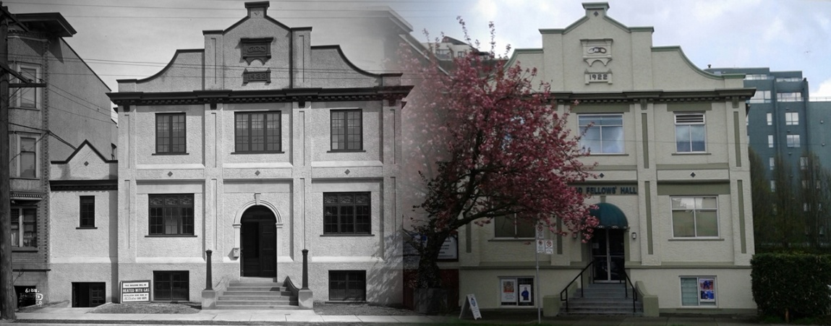
Fairview Hall at 1443 West 89th Ave is a heritage building built in 1922. https://vancouveroddfellows.ca/

Trades and Labor Council; Consolidated Street Railway Agreement; Sir Arthur Bigge;
H.W.C. Boak; F. Gourdeau; measles and scarlet fever; Independant Order of Odd Fellows; cemetery addition; Medical Health Officer; new library.

This transcript was made in May 2025 by Transcribimus volunteer Barbara Kearney-Copan.
Source: City of Vancouver Archives Series 31 (COV-S31, 715-D-02)
Volume 10, pages 357-360

[Volume 10 page] 357

Vancouver October 21st 1901

The Council met on Monday October 21st 1901
Present His Worship the Mayor and Aldermen Grant, Neelands, Cook, McPhaiden, McGuigan, Foreman, MacDonald [sic McDonald] and Wylie
The Minutes of last meetings were read and adopted.

Communications
From A.B. Greer etal asking for a sidewalk on 9th Av.
Referred to the Board of Works

From the Police Court Clerk reporting on the electric lights
Filed

From T.H. Cross, Secretary of the Trades and Labor Council asking for a copy of the Consolidated Street Railway Agreement
Moved by Alderman Grant
Seconded by Alderman Neelands
That his request be granted.
Carried

From Sir Arthur Biggs, Secretary of His Royal Highness, the Duke of York and Cornwall enclosing a copy of reply to the address presented by the Mayor
Filed

From H.W.C. Boak on behalf of a number of citizens objecting to the Market site being used for Library purposes.
Referred to the Finance Committee
[Note: Henry Westman C. Boak was a prominent early Vancouver lawyer active in the legal community around the turn of the 20th century. https://landscapesofinjustice.uvic.ca/archive/boak2.html]

From J. M^{c}Millan asking payment for land owned by him on the Capilano River included in water works dam site
Referred to the Water Committee

From F. Gourdeau, Deputy Minister of Marine and Fisheries enclosing a Quit Claim Deed of False Creek lying to the east of Westminster Av Bridge.
Filed
From A.N. Tregent asking for the passage of a Curfew By-Law.
Referred to the Police Committee

[Volume 10 page] 358

The following Reports were received and read:-

Health Committee
The Health Committee met on Wednesday October 16th 1901.
Present Aldermen McGuigan, Grant, Neelands and Wylie.

The following accounts were recommended for payment:-
Champion & White | Scavengering | $2.50
Clarke & Stuart | Supplies | 14.40
Center and Hanna | Burials | 64.00
The Province | Ads | 1.80
The World | Ads | 1.80
Industrial Woodyard | Supplies | 3.00
J.A. Flett | Supplies | 40.00
Fader & Co. | Supplies | 142.47
Scougale BrS. | Supplies | 5.65
Edgett & Co. | Supplies | 39.07
C. Q[?] Jones | Supplies | 1.75
R. Clark | Supplies | 1.75
B.C. Mills | Supplies | 108.73
J. Robertson | Nursing | 10.00
D^{r} A. Poole | Med At | 15.00
ThS. Dunn & Co. | Supplies | 39.97
A.M. Tyson | Supplies | 31.93
D^{r} M^{c}Ewen | Disbursements | 5.00
Scott & Kennedy | Supplies | 21.00
Cleeve Canning Co. | Supplies | 24.75
J. Dodson | Supplies | 31.20
D.M. Stewart | Supplies | 223.08
G.B. Lange | Supplies | 1.50
Edwards BrS. | Supplies | 8.05
Welsh & Nightingale | Supplies | 251.46
Buscombe & Co. | Supplies | 10.90
J. Johnson | Drayage | 2.50
Valley Dairy | Supplies | 130.29
Gua Co. | Supplies | 18.05
I.M. MacLean Estate | Med At | 22.50
M^{r} Jewell | Labor | 2.20

Communications
From the Health Inspector reporting a case of Measles and Scarlet fever.
Filed

[Volume 10 page] 359

From Fred Cochburn, Chairman Joint Committee of I.O.O.F [Independant Order of Odd Fellows] asking that a portion of the addition to the Cemetery be set aside for their puposes.
Laid over until next meeting.

From W.G. Walker, Clerk of South Vancouver asking that tank be moved off the road on the City property and that the City grade its share of the road around the new addition to the Cemetery.
Resolved that the City Engineer be instructed to have the tank moved as soon as possible.
The question of grading the roads was laid over.

From the City Auditor stating that he had collected $634.02 hospital dues since last report.
Filed

From R. Marpole offering 5½ acres on Fairview for a hospital site for $5000
Resolved that his offer be accepted subject to the passage of a By-Law to be voted upon by the electors such bylaw to be submitted on the same day as the general Municipal Elections

Resolved that the City Engineer be instructed to grade 3 acres of the addition to the Cemetery layout walks and put up a rough temporary fence around it.

Resolved that applications be invited for the position of Medical Health Officer such applications to be received up to Wednesday November 6th at 4 P.M.

sgd W.J. McGuigan
Chairman
Moved by Alderman McGuigan
Seconded by Alderman Foreman
That the Report be adopted
Carried

[Volume 10 page] 360

Finance Committee
The Finance Committee met on Friday October 18th 1901.
Present Alderman Neelands, McGuigan, Foreman and Wylie.

The following accounts were recommended for payment:-
Joseph Brown | Wreath | $5.00
Trimms & Co. | Supplies | 4.00
News Advertiser | Ads | 30.95
Carswell Co | Supplies | 1.30

sgd T.H. Neelands
Chairman
Moved by Alderman Neelands
Seconded by Alderman McGuigan
That the Report be adopted
Carried.

A Report was received from the Joint Committee of the City Council and Library Board re the New Library Building which was referred to the Finance Committee.

Motions
Moved by Alderman Grant
Seconded by Alderman Cook
That the following accounts be paid:-
McDonald BrS. | Drayage | $317.00
Geo Blair | Grading | 65.00
J. Williams | Rock | 771.00
Carried

The Council then adjourned

T.O. Townley
Mayor

ThS. F. McGuigan
City Clerk

Special Meeting of Council, See page 368

