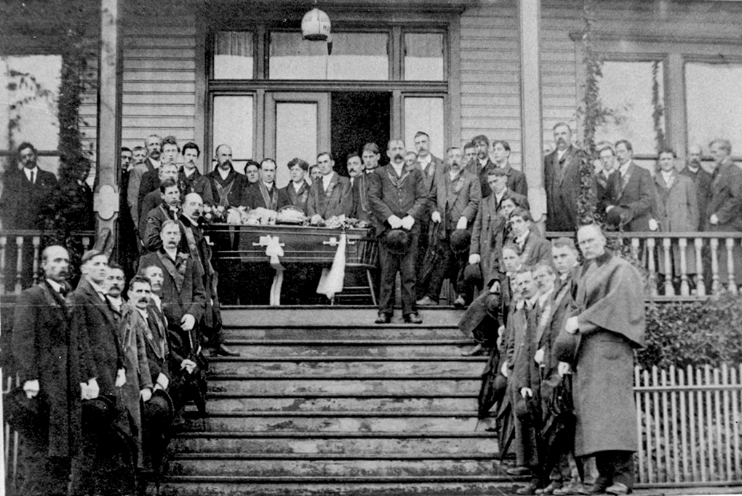

Funeral For A Victim Of Explosion In Extension Mines
Source: Ladysmith Archives, Date: 1909
https://www.communitystories.ca/v2/music-in-ladysmith_vie-musicale-ladysmith/gallery/funeral-for-a-victim-of-the-october-5th-1909-explosion-in-the-extension-mines/

Extension Mine Concert; Officer Borland; Detective Wylie; smoking concert; Water Works Dam; B.C. Electric Railway Co.; Albert Adams; Water Main Assessment By-Law.

This transcript was made in May 2025 by Transcribimus volunteer Barbara Kearney-Copan.
Source: City of Vancouver Archives Series 31 (COV-S31, 715-D-02)
Volume 10, pages 361-367

[Volume 10 page] 361

Vancouver October 28th, 1901

The Council met on Monday October 28th, 1901
Present His Worship the Mayor and Aldermen Cook, Foreman, Grant, M^{c}Phaiden, Neelands,
Wylie and Wood.
The Minutes of last meetings were read and adopted.

Communications
From W.W. McGuire asking that sewer pipe be extended to Lot 17, Blk 26, 200a
Referred to the Board of Works.

From Mrs Machin asking for the use of the Market Hall on November 28th for a concert in aid of Extension Mine Sufferers.
Referred to Alderman Foreman and Market Clerk
[Note: fire at the Extension Mine Fire in Ladysmith, September 30 1901
https://www.ladysmithhistoricalsociety.ca/histories/mining/1901-extension-mine-fire/]

From R.A. McCulloch et al asking for walk on Westminster Road from 9th to 12th Avenues.
Referred to Board of Works

From R.G. Tatlow asking for a further appropriation of Four Hundred dollars for Park purposes.
Referred to the Finance Committee

From D Brockwell asking that the lane in rear of his premises be opened up.
Referred to Board of Works.

From R. McLeod asking that sidewalk in front of Lots 14 and 15, Blk 42, Howe Street, be moved out.
Referred to the Board of Works

From A.St. G. Hamersley, City Solicitor re Water Main Tax.
Laid over

From J.W. M^{c}Intosh, Police Court Clerk reporting on Street lights.
Referred to Light Committee.

[Volume 10 page] 362

Reports were received from His Worship the Mayor and from Chief North re the suspension of Officer Borland and Detective Wylie for disorderly conduct
Moved by Alderman Wood
Seconded by Alderman Cook
That both reports be referred to a special meeting of the Police Committee. The men to remain suspended until further action
Carried.

The following reports were received and read.

Fire and Police
The Fire and Police Committee met on Thursday October 24, 1901
Present Alderman Wood, M^{c}Phaiden and MacDonald [sic McDonald]
The minutes of the last meeting were read and adopted.

The following accounts were passed for payment:-
C. Thorst | 12.35
W.J. McGuigan | 5.00
S. James | 2.00
J.B. Hart | 10.00
C.M. Hawley | 1.75
J.H. Carlisle | 2.50
Hunt & Foster | 269.00
Shelton & Co. | 10.60
Atkins & Johnson | 1.00
J. Carnahan | 31.00
Valley Dairy | 1.65
Evans C. [Coleman] & Evans | 6.30
Thos Dunn & Co. | 13.18
Hinton Elec Co. | 145.56
W.C. Marshall | 3.50
Timms & Co. | 4.25
A. Savard | 12.20
Gross McNeill | .50
H.A. Edgett & Co. | 6.65
J. Dodson | 21.50

Communications
From Norville P. Ross resigning his position as Fireman
Resolved that his resignation be accepted to take effect on the 4th inst.

[Volume 10 page] 363

The Chief recommended that Pearson be appointed in his place
It was resolved that Pearson be appointed on the Chiefs[sic] recommendation at a salary of $47.50 per month
[Note: J. Pearson replaced Mr. Ross who had resigned from the fire department;
https://www.newspapers.com/image/62949819/?match=2&terms=Fire%20chief%20Pearson&search-id=51961022-385d-46aa-81a6-29e5b6cfb0d3&search-rank=14]

J.H. Carlisle reported that he had purchased a horse for $150 giving in exchange his old horse
It was resolved that his report be accepted and filed

A.N. Tregent’s communication re curfew bill was laid over until next meeting
The Board then adjourned.

Moved by Alderman Wood
Seconded by Alderman Wylie
That the accounts be paid as read and the remainder of the report be referred back to the Committee.
Carried

Water & Market
The Water and Market Committee met on Wednesday Oct 23 1901
Present Aldermen Foreman, Grant and Wylie
The minutes of the last meeting were read and adopted.

Communications
From the Rugby Football Club asking for the use of the City Hall on Nov. 9th for a smoking concert and for permission to sell beer at said concert.
Mr Tait, the Captain of the Club, was referred to the Market Clerk for terms.
[Note taken from Wikipedia - Smoking concerts emerged in the 1860s as private entertainment organised by aristocratic and bourgeois amateur music societies and were intended exclusively for men.^{[1]} At these functions men would smoke and speak of politics while listening to live music.^{[2]}]

From John M^{c}Guillan claiming ownership to the ground upon which are situated the Water Works Dam and Buildings and offering to sell or lease the same on favourable terms
Referred to the City Solicitor

It was moved by Alderman Grant that the Water Main By-Law be …

[Volume 10 page] 364

… amended to the following effect: That all four inch pipe and upwards be charged at the rate of three cents per foot frontage provided the rate of 5 cents per foot charged for 1901 be paid
Carried

The following accounts were recommended for payment:-
Robertson Godson Co. | 1943.67
B.C. Mills | 3.09
M^{c}Donald Marpole Co. | 6.50
Welsh & Nightingale | 3.00
Boyd Burns & Co. | 18.57
Can. Gen. Elec Co. | 3.60
Thos. Dunn & Co. | 97.95
Pay Roll | 1573.41

The Board then adjourned.

Moved by Ald. Foreman
Seconded by Ald. Wylie
That the report be adopted as read
Carried.

Board of Works
The Board of Works met on October 24, 1901
Present Aldermen Grant, M^{c}Phaiden and Wood
The minutes of the last meeting were read and adopted.

Communications
From L. Logan re accident on Georgia Street on 13th inst.
Engineer to see Mrs Logan and report.

From P.A. Farline re condition of lane between Cordova and Hastings Street east of Carrall
Engineer to attend to.

From C.E. Turner applying for permission to erect open shed at rear of his lot on Pender Street
Location approved. Referred to the Building Inspector for attention.

From A.B. Greer et al applying for walk …

[Volume 10 page] 365

… on South Side Ninth Avenue from Spruce to Oak and grading
Referred to Engineer to report.

From R.L. Spencer as agent asking that sidewalk be fixed around Lot 38 S.W. Corner of Nelson and Granville Street.
Ordered to be done.

From the Trustees First Baptist Church asking for new walk South Side of Dunsmuir from Cambie to Homer Street and also crossing on east side Hamilton and Pender Streets.
Engineer to examine.

From W.G.Walker C.M.C. [Certified Management Consultant?]re 16th Ave
[minutes do not indicate content of correspondance]
Attended to.

From F. Domoney et al asking that he be given sewer pipe to cross the Street in making connections.
To be notified that By-Law must be carried out.

From T.A. Smith complaining of brush on Lot 4, Blk 83, Sub 181.
Mr Kilmer to report.

From K. Fleming asking for walk 132 feet on Cardero Street east side and south from Comox and grading of Street
132 feet 3 plank walk to be put in.

From J.W. Deptford asking for crossing opposite Lots 3 and 4, Blk 109, D.L. 301
Engineer to look into and report.

From D. Donaldson on behalf of Wesley Church asking for cement walk on Burrard Street opposite Church under local improvement By-Law
Engineer to report.

Ward Foreman was instructed to clear lane back of Lot 10, Blk 300, D.L. 526
From City Solicitor in reference to resurvey of 264a
Laid over.

[Volume 10 page] 366

Moved by Alderman Wood
That the B.C. Elec. Ry. Co. be notified to immediately place the cinder path on Pender …
… Street in the same condition that it was before they started grading the same and also to move an electric light pole at the corner of Ontario and Dufferin and Hastings and Burrard Streets and that the Telephone Company be notified to move poles on Westminster Road where grading has been done as the same are in a dangerous condition
Carried.

The following accounts were passed for payment:
Pay Roll | 2863.06
T. Dunn & Co. | 116.25
Champion & White | 5.00
N.G. Foster | 2.50
B.C. Elec | 7.00
V. Straube | 1.00
Robertson & Hackett | 53.21
B.C. Mills | 39.00
W.L. Tait | 150.43
W.S. Hurst | 1206.00

The Board then adjourned.

Moved by Alderman Grant
Seconded by Alderman Wood
That the report be adopted as read.
Carried.

Finance
The Finance Committee met on Oct 25, 1901
Present Aldermen Neelands, M^{c}Guigan, Foreman and Wylie
The minutes of the last meeting were adopted as read.

Communications were received from the Joint Committee of the Free Library Board and City Council recommending the awarding of the Contract for building the Library to Albert Adams
Laid over.

[Volume 10 page] 367

The following accounts were passed for payment:
Tax Collector | 14.60
Jas Carnahan | 7.00
N. Lavere | 3.90
J.S. Tait | 150.00
W. Murray | 25.00
J.J. Sparrow | 10.00
Can. Gen Elec Co. | 3.60

The board then adjourned.

Moved by Alderman Neelands
Seconded by Alderman Wylie
That the report be adopted as read
Carried.

Notice of Motion
Alderman Foreman gave notice that at the next regular meeting of the Council he would introduce a By-Law to amend the Water Main Assessment By-Law.

The Council then adjourned.

T.O. Townley
Mayor

ThS. F. McGuigan
City Clerk

